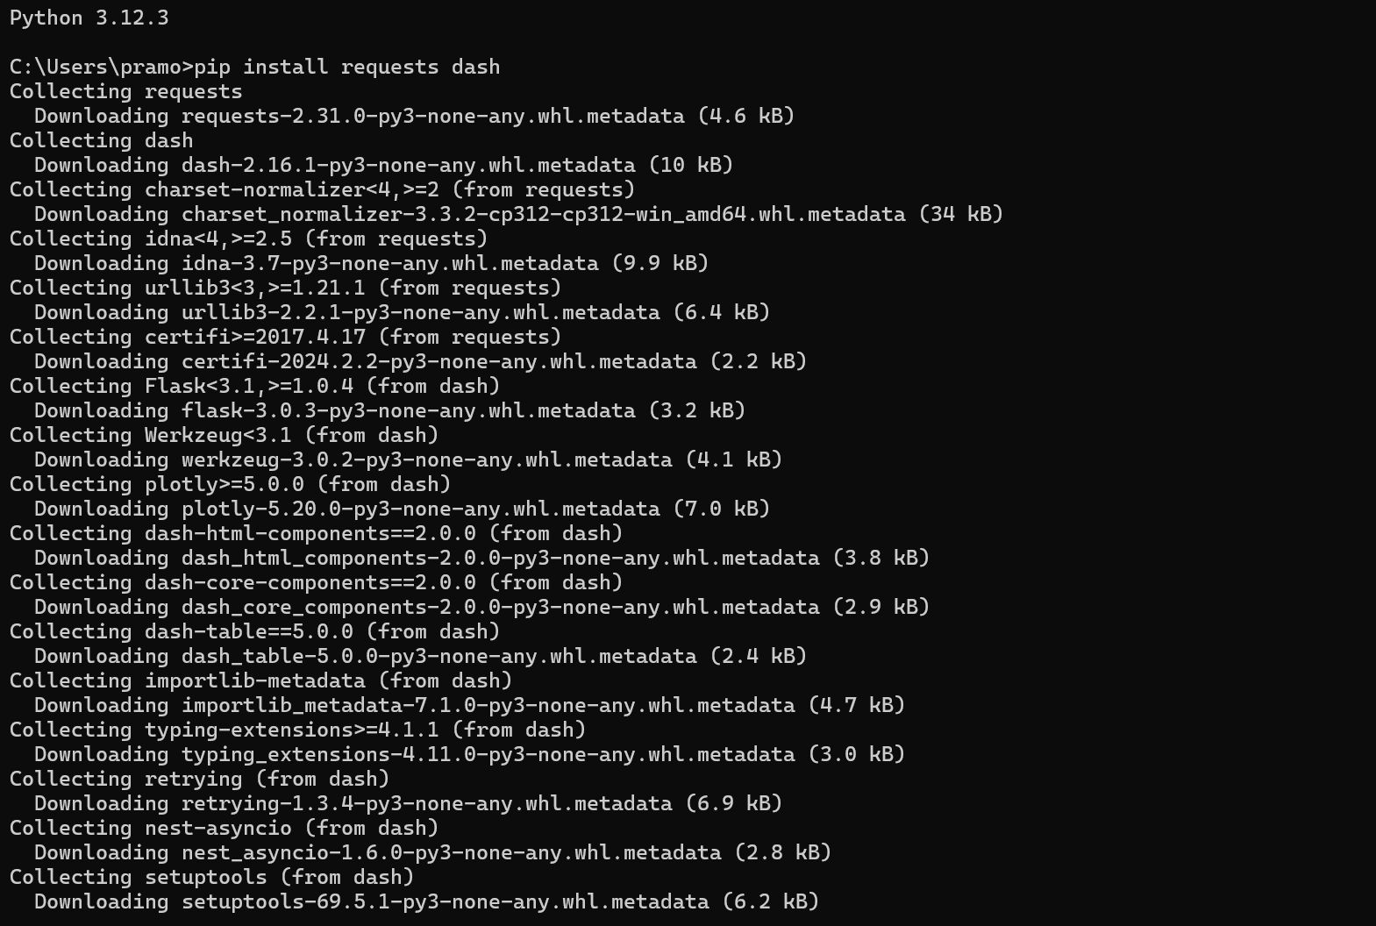

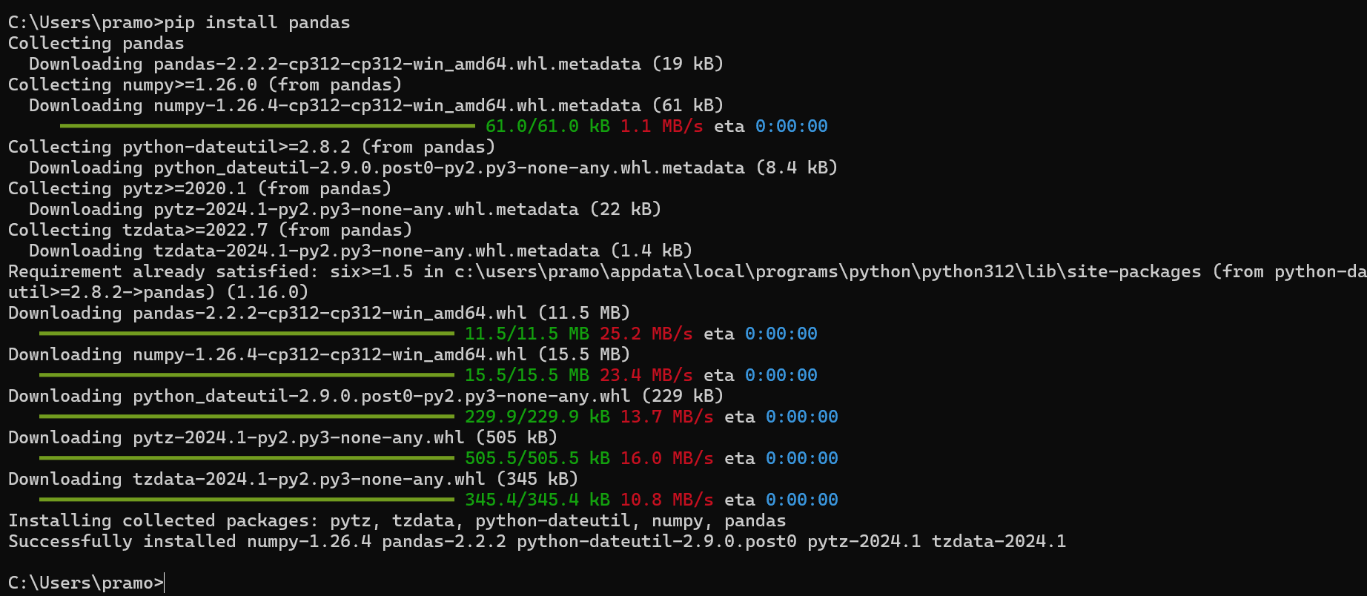  
  
The implemented code utilizes the Fixer.io API to fetch live currency exchange rates. A Dash app is created to display these rates in a dashboard format, updating every 10 seconds. The layout includes a title, a division for displaying the rates, and an interval component for periodic updates. Upon execution, the dashboard successfully renders the current exchange rates for various currencies, providing a user-friendly interface for tracking currency values in real-time.